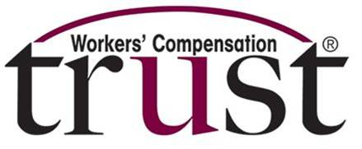

If you are required to drive a vehicle and interact with other people, there are steps you can take to reduce the potential exposure to COVID-19 coronavirus.

It all starts at the beginning of your shift, according to AAA.

- Before you leave your home, wash your hands thoroughly at the sink for 20 seconds with soap and water.
- Throughout your day, whenever you receive any sort of equipment, spray the equipment with disinfectant spray or wipe it down using disinfectant wipes.
- A good item to have while on the road is a pack of nitrile gloves. Wear gloves for every job you start through the day, to reduce the chance that you contract something from any given location you visit throughout the day.
- Following the completion of a job, disinfect your hands and wipe down your vehicle.
- Wipe down the inside of the vehicle, such as the door, dashboard, seat, door hand, and any exposed surfaces with spray disinfectant or disinfectant wipes after anyone enters your vehicle.
- Have a small trash bag to dispose of soiled gloves, towels and wipes; make sure that you dispose of that small trash bag at the end of each shift, according to AAA.
- A few items that you probably handle every day that might not be getting the attention it should is your credit card, corporate fuel card, or cash. These items can hold the virus so it’s a good idea to wear gloves whenever you handle these items.
- At the end of your shift, wash your hands again thoroughly at a sink for 20 seconds with soap and water.

To make sure that you’re using products that will properly disinfect your vehicle, the Environmental Protection Agency has a site that lists all the products that currently meet its criteria for use against COVID-19. https://www.epa.gov/pesticide-registration/list-n-disinfectants-use-against-sars-cov-2

