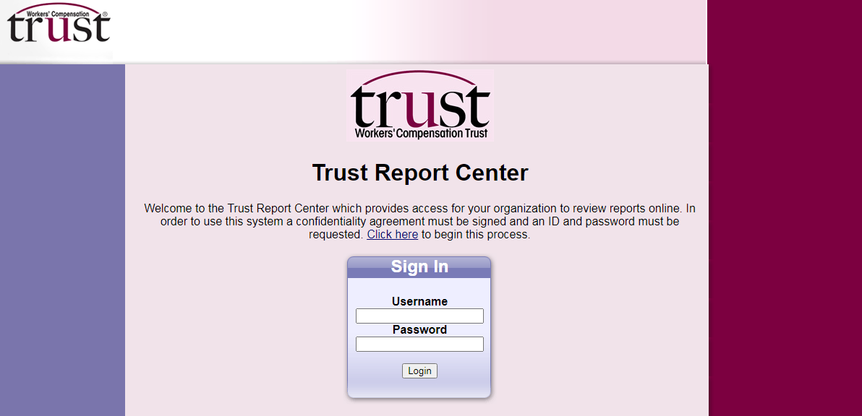
⇒ The following screen will appear. Click on the click here Link to begin the registration process.
Trust Report Center Registration Instructions
⇒ Log onto the Internet and go to www.wctrust.com to enter the Trust’s website
⇒ Click on Report Center from the Quick Links box located on the right side of the home page as shown below
It will take a few days to receive your username and password.

Once you log in you be able to choose which report you would like to run.

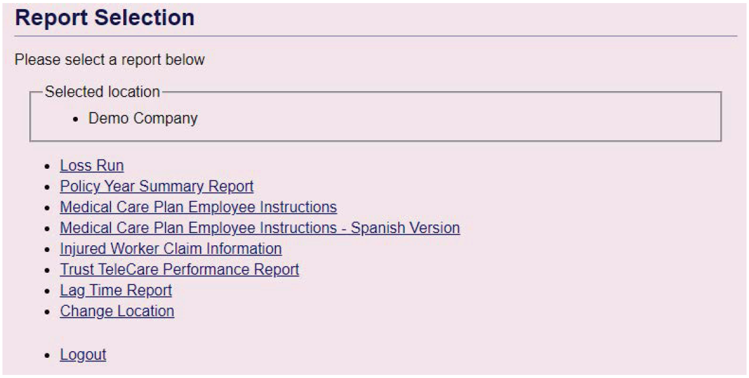

REPORT DESCRIPTIONS

- Loss Run
The loss run is a listing of all claims reported under your policy. It shows employee name, date of injury, status, department, cause of accident and body part. It also lists all payments made, recovered or reserved.

This information can be downloaded into Excel for sorting.

- Policy Year Summary Report
The policy year summary report shows total number of claims (lost time and medical only), Payments, Reserves, Recoveries and Total Incurred by policy year.

- Medical Care Plan Employee Instructions
The medical care plan employee instructions is a posting notice that should be posted in each work facility in a conspicuous place so it is visible to all employees. It includes instructions for employees in the event that they are injured on the job.

- Medical Care Plan Employee Instructions - Spanish
The medical care plan employee instructions is a posting notice that should be posted in each work facility in a conspicuous place so it is visible to all employees. It includes instructions for employees in the event that they are injured on the job.

- Injured Worker Claim Information
A list of open claims will appear at the bottom of the screen displaying Claim Number, Injured Worker Name, Injury Date, Close Date and Status. You can choose any individual claim or you can filter the results to find a specific claim faster.

The Injured Worker Claim Report allows you to view a Claim Summary, File Notes and Payment History for that specific claim.

- Trust TeleCare
The Trust TeleCare Report shows how your organization utilizes Trust TeleCare. Trust TeleCare provides a simple and effective way to manage work-related injuries. Trust TeleCare is available 24 hours a day, 7 days a week. It allows employees immediate access to a medical professional to assist in making a decision about when first aid is appropriate or if seeking further medical care is appropriate.

- Lag Time Report
The Lag Time of Claims Report shows the amount of time it took for each individual claim to be reported to the Trust for the 3 most recent policy periods.

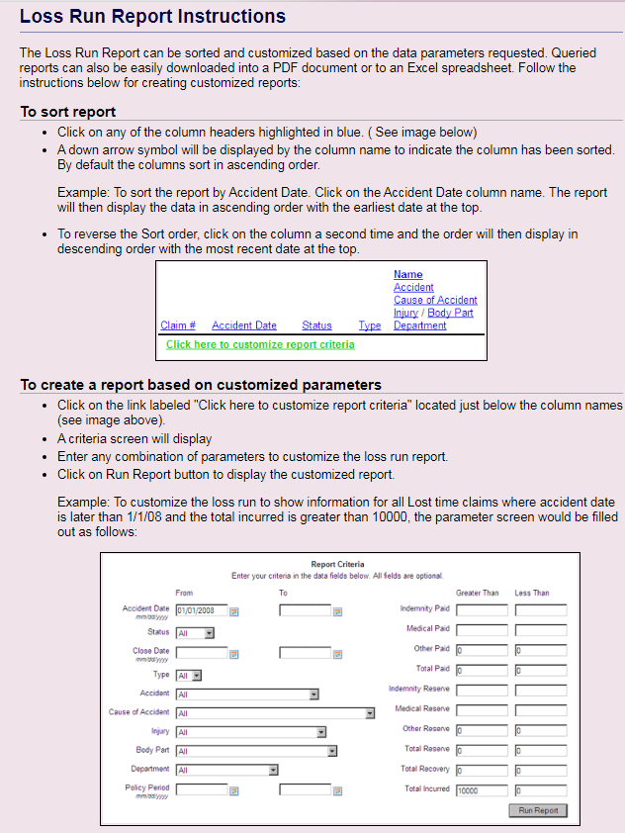

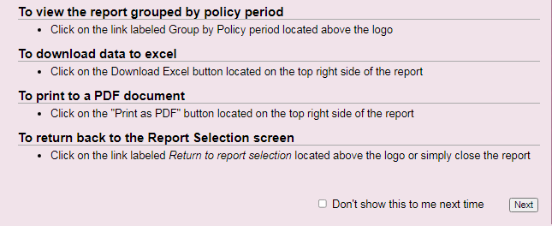

Any questions, please call (203) 678-0123 or email losscontrol@wctrust.com.

